Testcase 1: With default filtering verify API values against UI.
- Navigate to admin portal payments tab.
- Then for Enrollment group and RIN select all and search it.
- In the network tab we will get all the payments through API verify them against the UI.
- 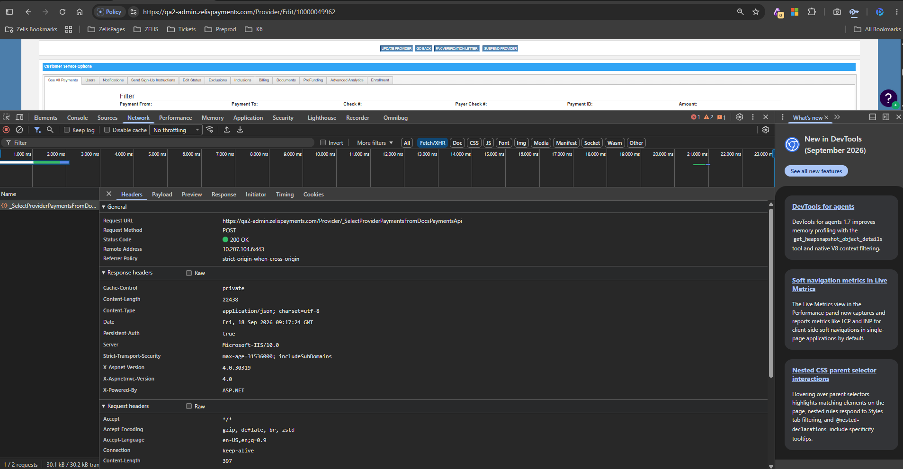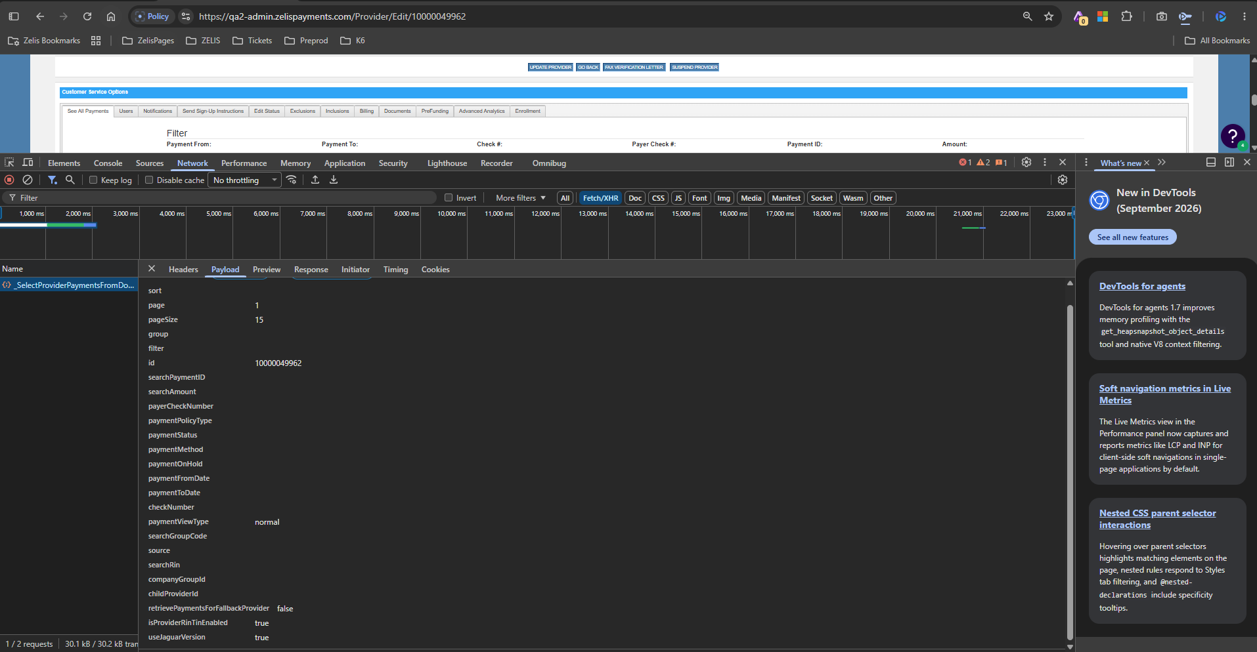

Response:
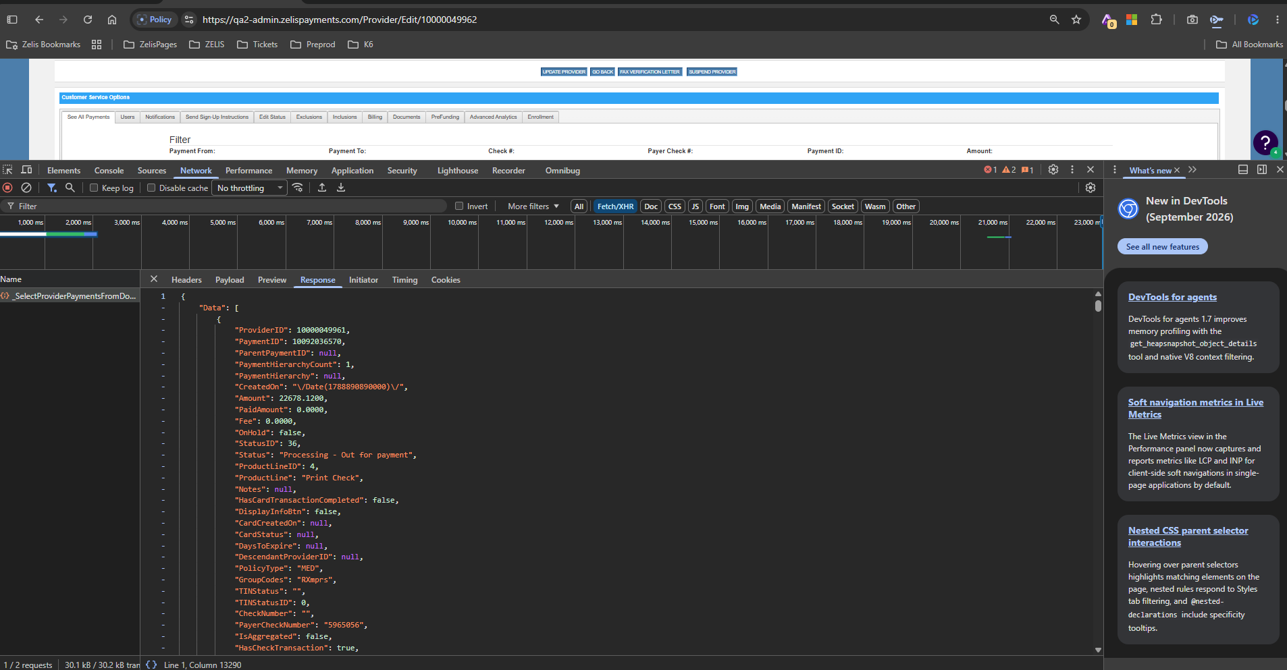

UI:
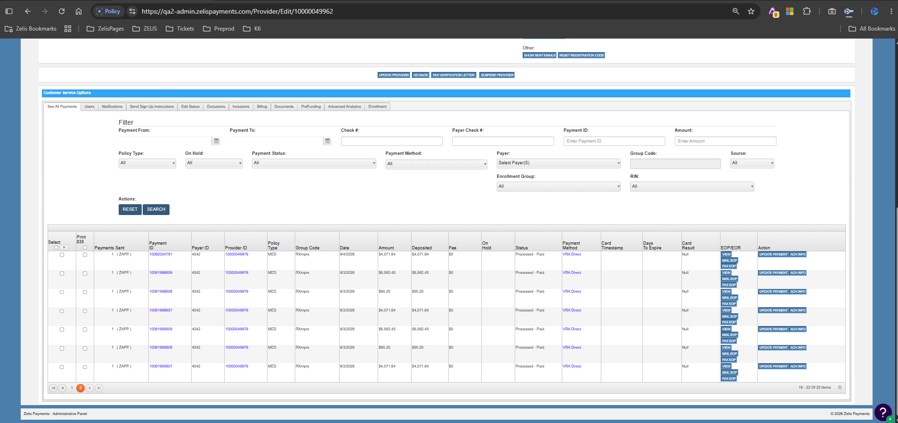
Total 22 payments.

Testcase 2:
- Navigate to admin portal payments tab.
- Then for Enrollment group select a group from dropdown and RIN select all and search it.
- In the network tab we will get all the payments through API verify them against the UI.
With group Filters:
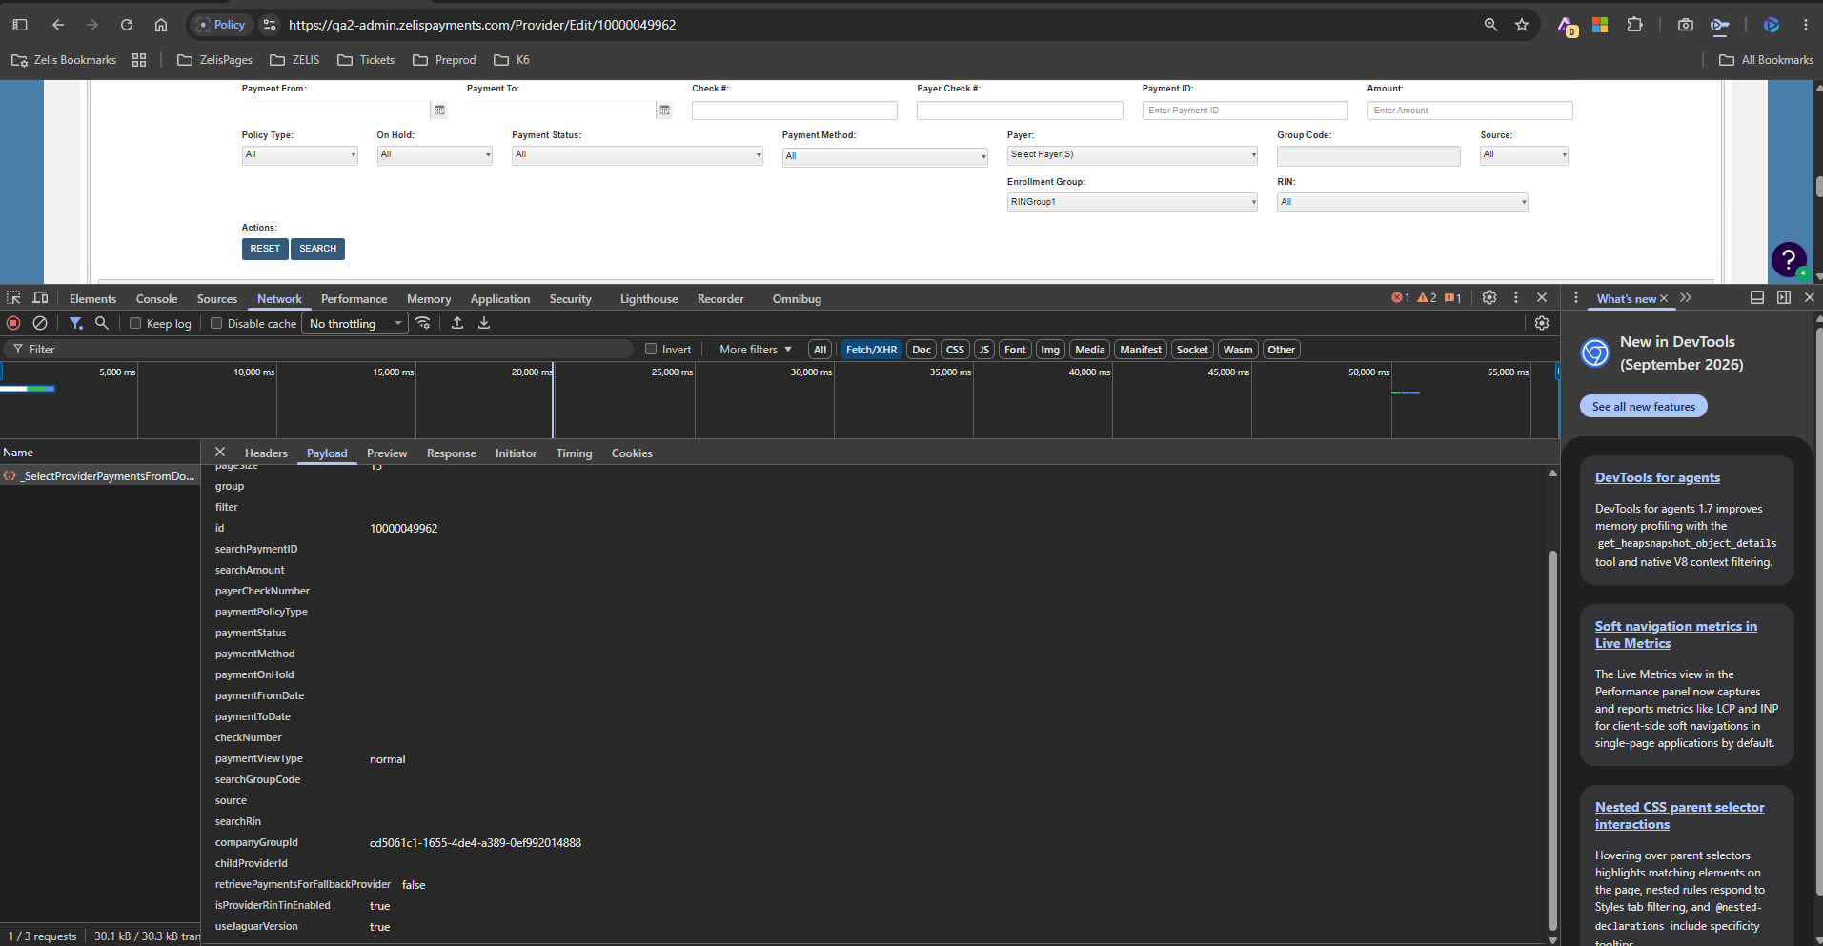
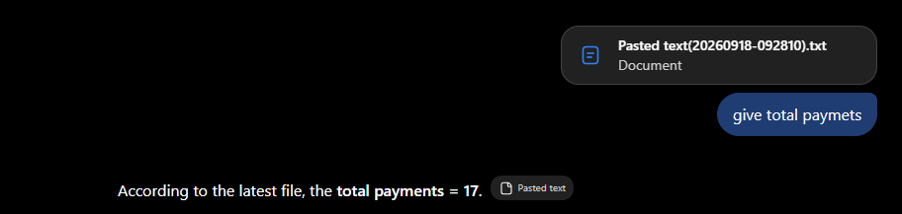
We are sending new parameter company groupid.
IN API I see 17 payments and UI also the same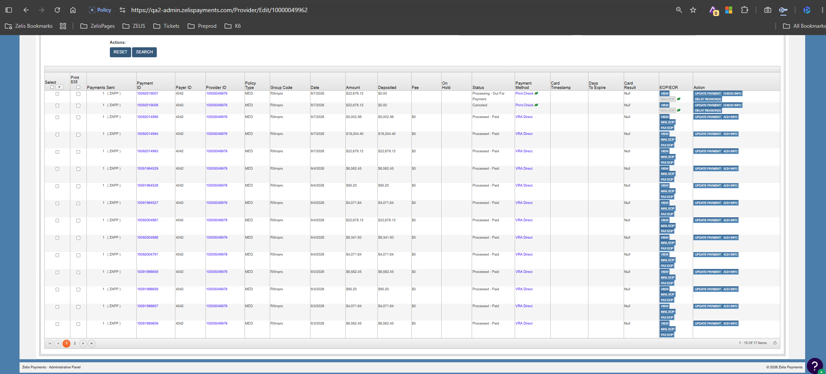
Testcase 3:
- Navigate to admin portal payments tab.
- Then for Enrollment group select a group from dropdown and RIN dropdown select a single rin from it and search
- In the network tab we will get all the payments through API verify them against the UI.

With both group filter and Rin filter:
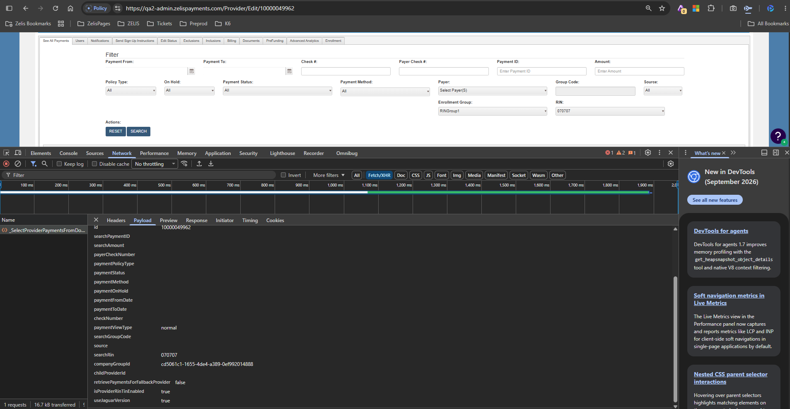
Search Rin is new parameter which we are passing.
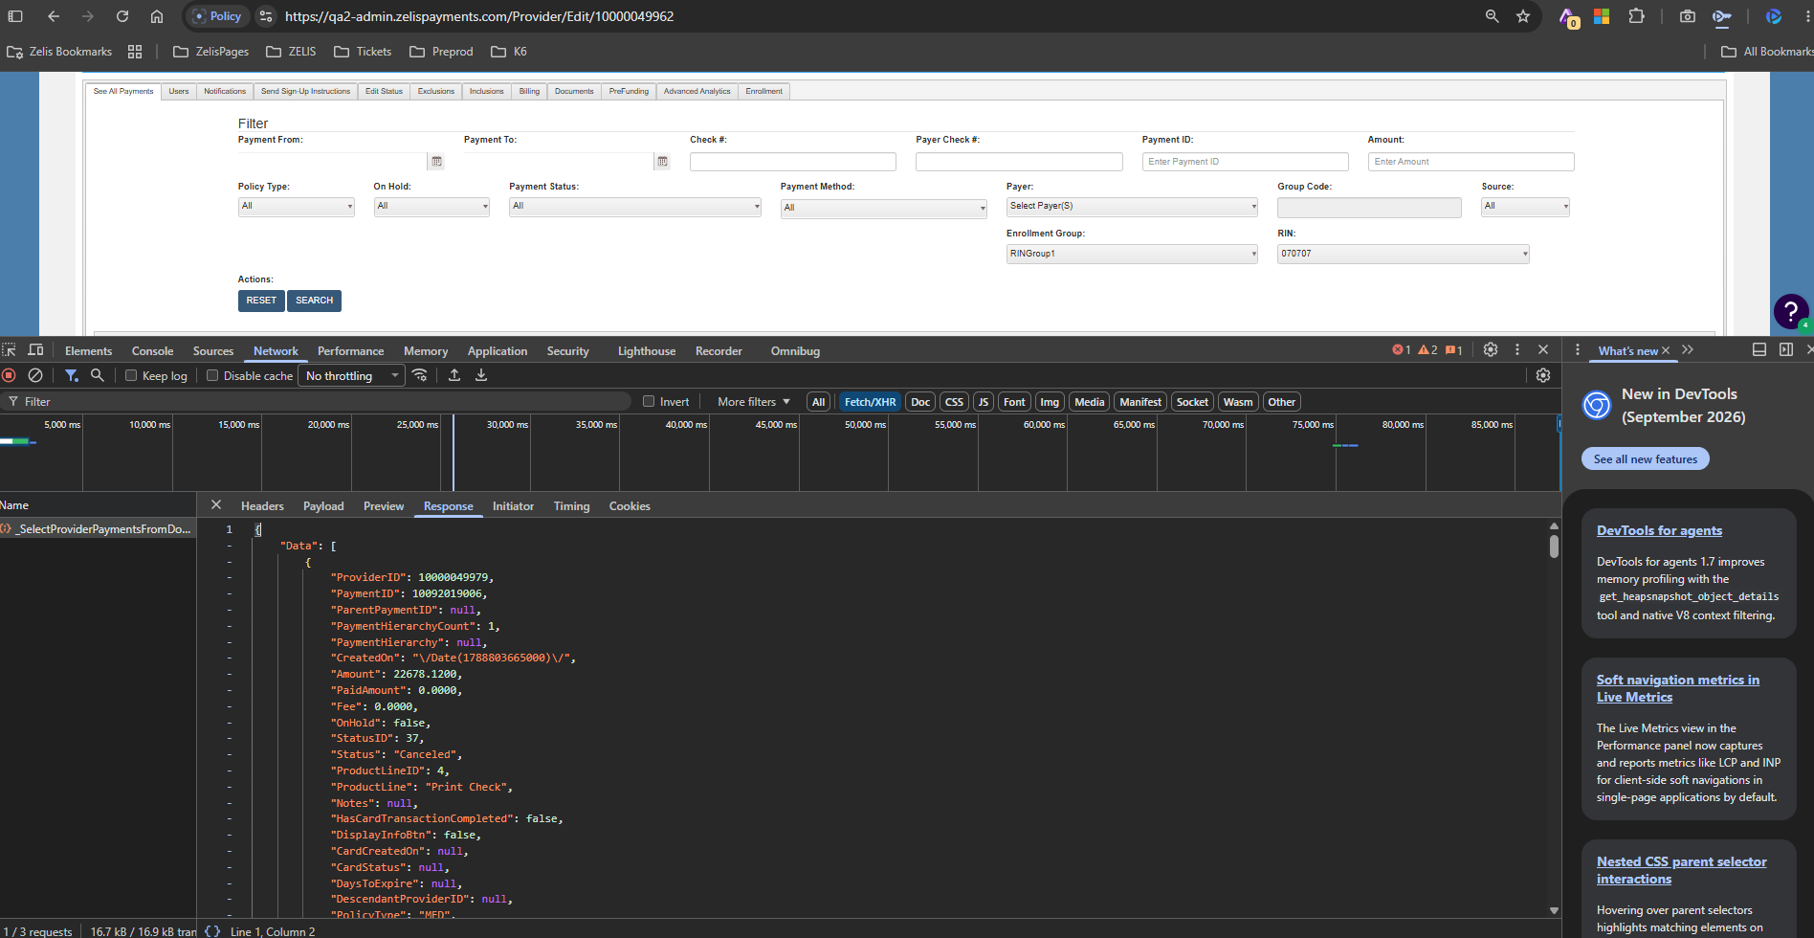
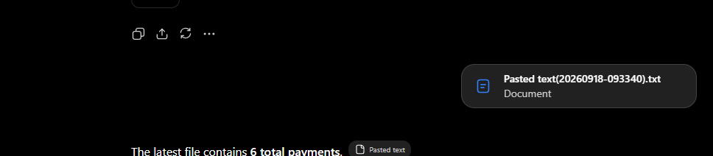
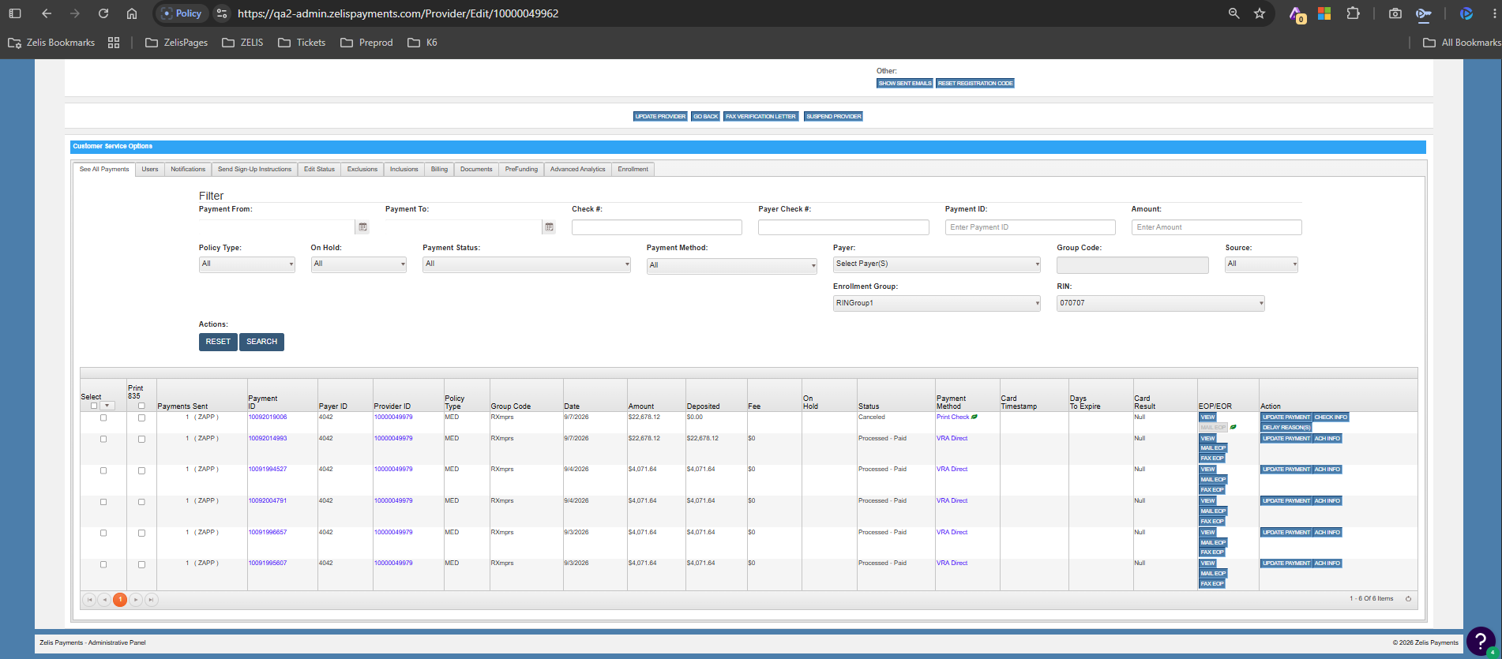
Testcase 4: For unassigned only:
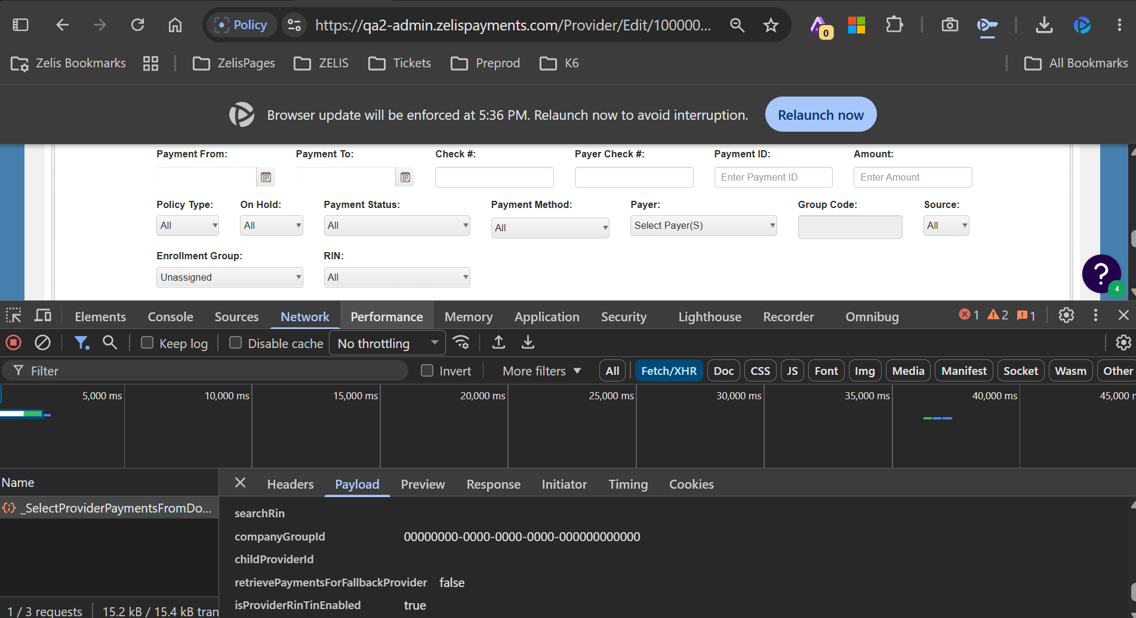
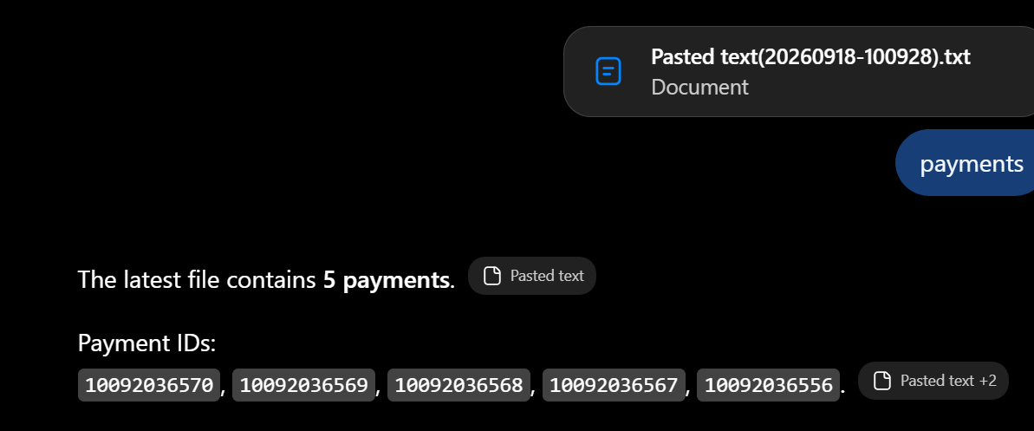
Ui Payments:
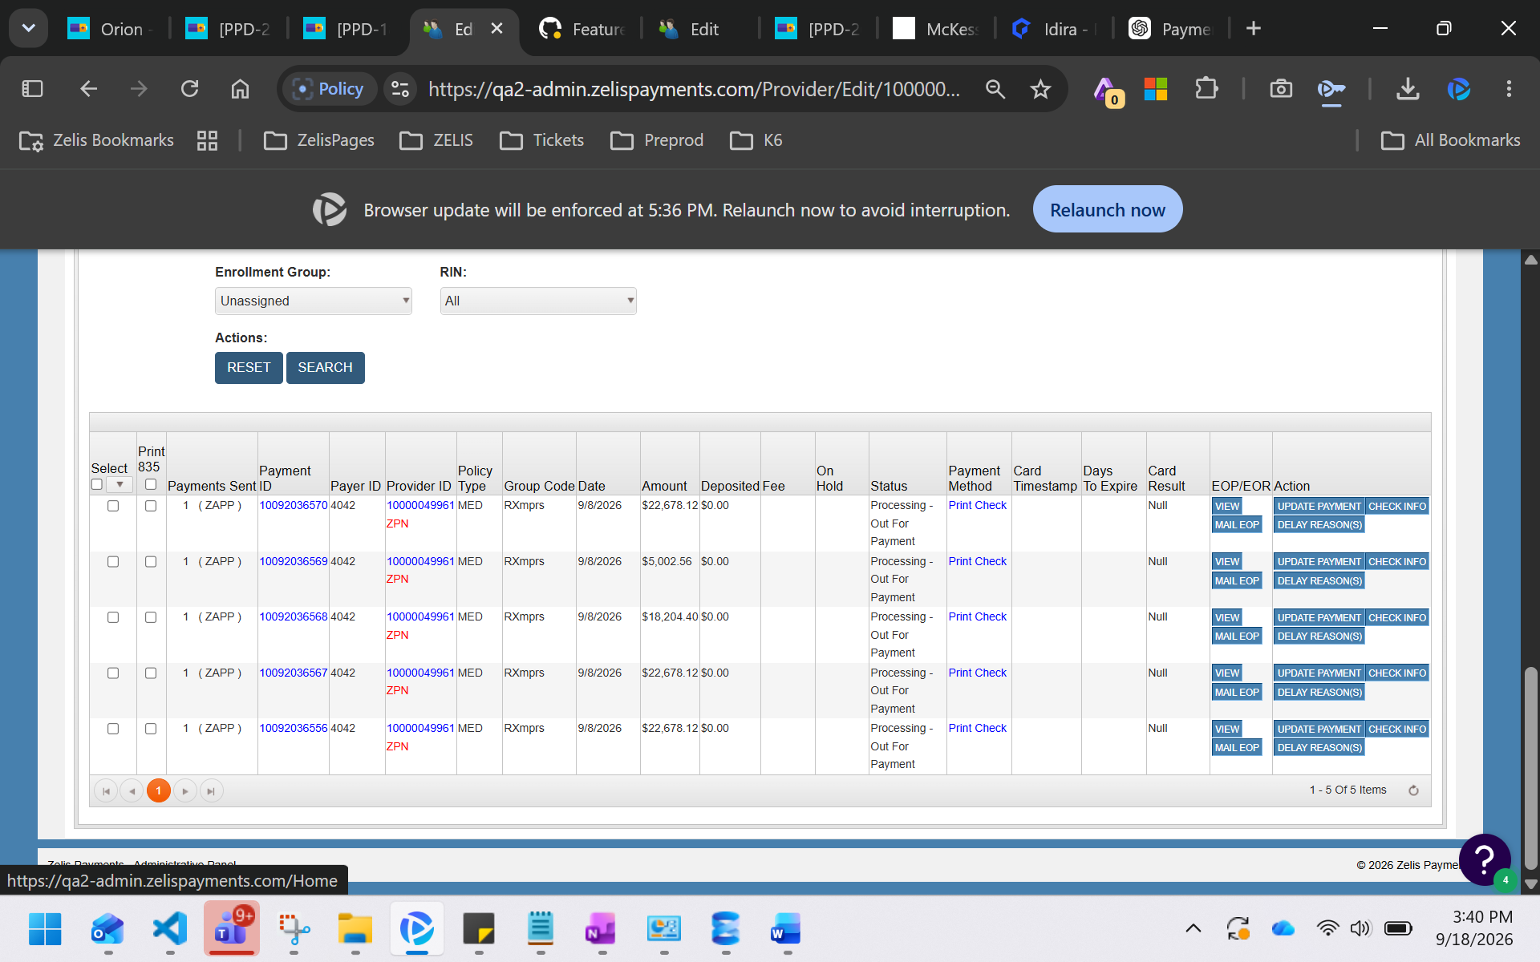

Testcase 5: Selecting only RIN’s and group selection all:
